Stoney Point Camp Returning Volunteer/Staff Application
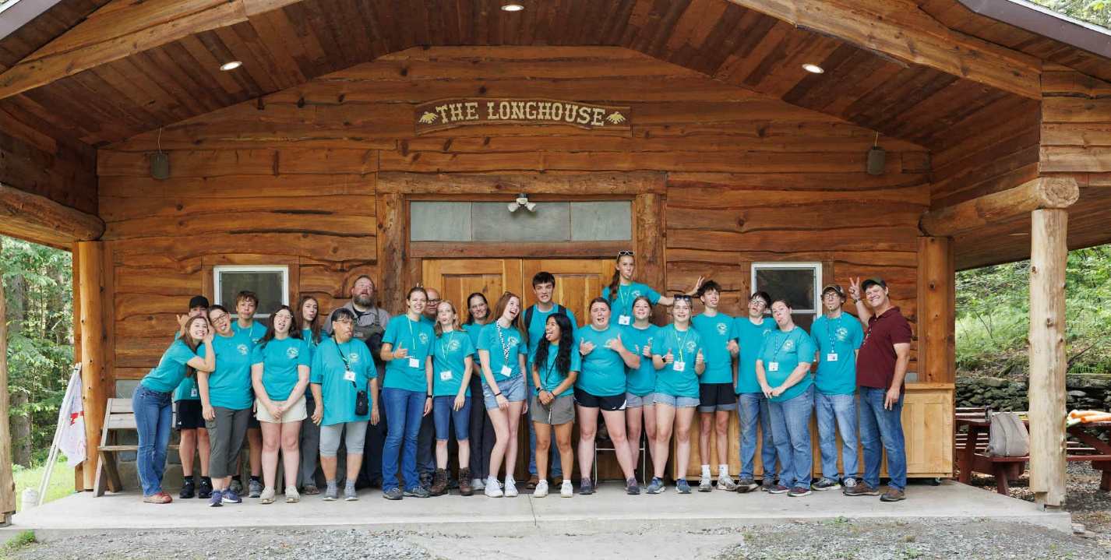
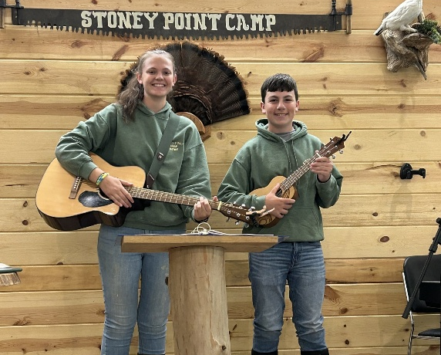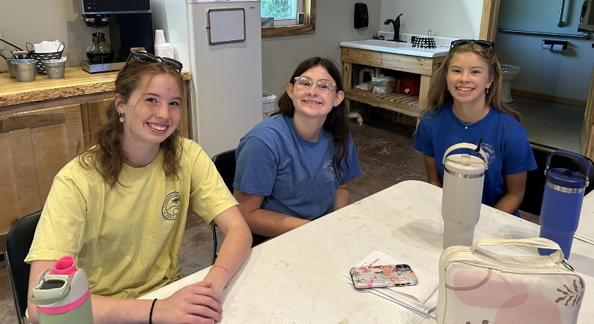

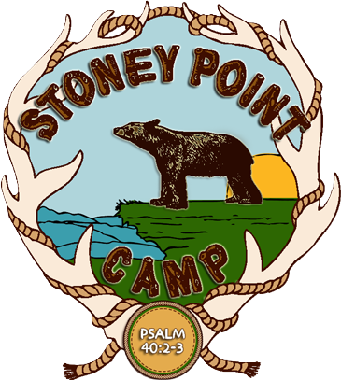
1460 Stoney Point Rd.
Wyalusing, PA 18853
www.stoneypointcamp.com
email: info@stoneypointcamp.com
570.746.1428
Dear Return Applicant,
Thank you for considering serving at Stoney Point Camp again this summer ! We join you in praying that God will do incredible work through your service to Him this summer, with hopes of it being here at Stoney Point Camp. Our camp is a God-centered Christian ministry with a single purpose: to help individuals get to know and grow closer to Jesus Christ. With all its beauty and life lessons, the great outdoors is a powerful tool in achieving this goal.
Stoney Point Camp sets on over 150 acres of beautiful farmland and woodlands, where most camp activities offer unique, teachable moments from nature and interactions with horses. Nearly all our programs take place outdoors, providing opportunities for both fun and learning.
Stoney Point Camp functions as God’s extension of the local church, partnering with believers to evangelize and disciple others. If you share this mission and are passionate about helping others experience spiritual growth, Stoney Point Camp is the perfect place for you!
There are many different areas where your help is needed throughout the summer. Volunteers must be at least 15 years old. Please let us know your availability and which areas you would like to serve in, and we will do our best to create a schedule that works for both you and the camp.
All volunteers and staff are required to participate in Counselor-in-Training (CIT) week, which includes essential training in CPR, First Aid, horse-wrangling for the wranglers, camp policies, and counseling. There is no charge for CIT camp.
Our summer programs include:
- Counselor In Training Camp (CIT)
- Junior Day Camps (Weeks 1 and 2)
- Horsemanship Camp
- Teen Girls Adventure Camp
- Teen Boys Adventure Camp
Additionally, we organize activities for individual churches, families, and other Christian organizations throughout the summer.
We look forward to partnering with you as we work together to make this a transformative summer for all involved!
Filling out this application does not guarantee employment or placement for volunteer work at Stoney Point Camp. It is the first step. Please send this completed application to:
Please send your completed volunteer application to:
Director Tom Hiduk
C/O Stoney Point Camp, 1460 Stoney Point Rd., Wyalusing, PA 18853
The most crucial part of Stoney Point Camp is that we practice what we believe and value. As volunteers, we want to work on the same mission. Please read over our Doctrinal Statement, Values, Mission, and Goals. Please sign below if you feel this is also your heart and mission.
Our Goals
To provide each camper with fun, adventurous activities not generally found at home. To develop growth in the camper spiritually, physically, intellectually, emotionally, and socially.
To teach skills and sound judgment in activities involving an element of risk.
Provide appropriate camping programs for age levels, abilities, and camper interests.
To develop good health habits.
To provide hearty, healthy meals that are nutritionally balanced and delicious. To provide healthy and balanced physical exercise.
To develop a camper’s mindset to “treat others as they would like to be treated.”
To teach campers how to responsibly and compassionately care for animals and property put under their care.
To promote the importance of the family unit and the church body in the camper's heart.
Doctrinal Statement
We believe…
1. In the Bible is the inspired and the only infallible and authoritative written Word of God. (II Tim. 3:16-17; II Pet. 1:19-21)
2. In one God, eternally existent, manifesting Himself in three persons: God the Father, God the Son, and God the Holy Spirit. (Mt. 3:16-17; II Cor. 13:14)
3. In the Biblical account of the six days of creation. (Gen. 1:1-2:4)
4. In the deity, incarnation, and virgin birth of our Lord Jesus Christ. (Jn. 1:1-2, 14; Is. 7:14; Matt. 1:18-25)
5. In the sinless life of Jesus Christ on earth and the finished substitutionary atonement of
Jesus Christ on the cross. (II Cor. 5:21; Rom. 5:6-9; Lk. 23:46; Jn. 19:30)
6. In the bodily resurrection of Jesus Christ from the grave. (John 20)
7. In the rapture of the Church at the second coming of Jesus Christ to meet His saints in the air. (I Thess. 4:16-17)
8. In a literal hell, it is the eternal punishment for the unsaved. (Lk. 16:19-31; Rev. 20:11-15)
9. In salvation by grace alone through faith alone in the final redemptive blood sacrifice of
Jesus Christ on Calvary. (Eph. 2:8-9)
10. In the God-ordained institution of marriage between one man and one woman. (Gen. 2:18-25; Eph. 5:22-33)
Our Mission
The mission of Stoney Point Camp is to proclaim the glory of God by offering to the local church a place where they can come and build disciples for Christ’s Kingdom through the strategy of teaching the Word of God through preaching, individual and family activities, outdoor activities, and counseling in one-on-one or group settings.
Our Values
As a camp, we seek to develop these values through our programming and in the lives and hearts of our staff.
We value Scripture. Above all else, we are governed by the truths of the living Word of God. They are the Words of Life. It is the truths of scripture that gives direction and change lives.
We value that all men are made in the Image of God. Every staff member, volunteer, camper, vendor, and visitor made by God and for God. We are responsible for seeing each other the way God sees us and serving each other accordingly.
We value the local church. God has chosen the assembly of called-out believers to do His work in the lives of men today. Our job as a camp is to be active in building God’s church both personally and in our programs.
We value servant leadership. Our job as believers is to serve others, not to be served. We desire to follow Christ’s example and to serve one another.
We value what God values. We seek not to be conformed to the world but transformed, set apart by God. We are in the world to reach the world so that the world through Him might be saved.
I have read the camp’s mission, value, goals, and doctrinal statement and agree with them.
Click or tap here to enter text.
(Signature)
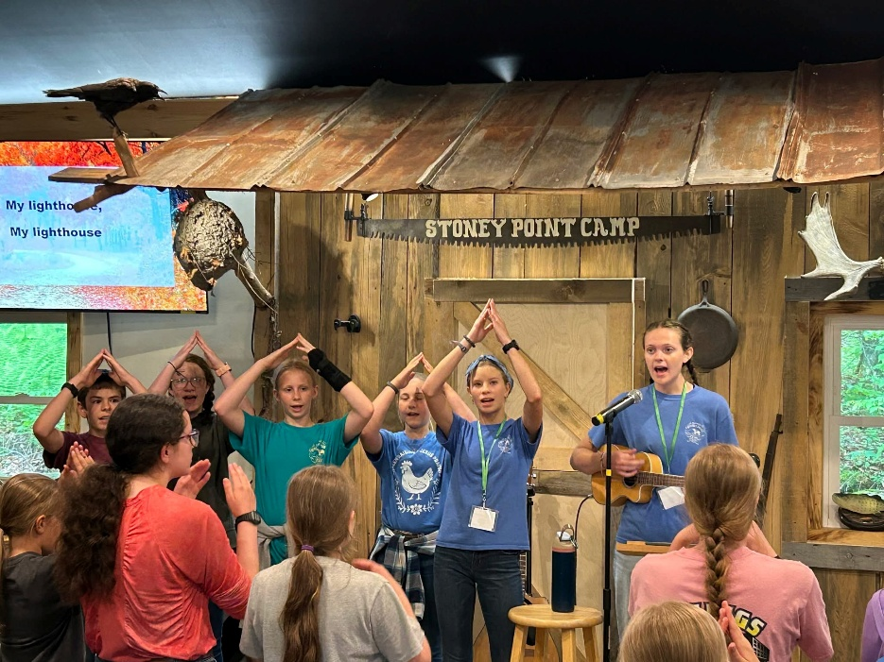

Returning Volunteer/Staff Application
Name: Click or tap here to enter text.
Phone Number: Click or tap here to enter text.
Address: Click or tap here to enter text.
Email Address: Click or tap here to enter text.
Male ☐ Female ☐ T-shirt size: Click or tap here to enter text.

Do you have any allergies or physical restrictions? Yes ☐ No ☐
If yes, please elaborate Click or tap here to enter text.

Pastor or youth leader’s Name & Church: Click or tap here to enter text.
Reference: Click or tap here to enter text.
Are you over 18 years of age? Yes ☐ No☐
If yes: Please complete the Child Abuse History Clearance form online (Volunteer) Pa.gov Child Abuse History Certification (CY113) and turn into Stoney Point Camp.

If under the age of 18, please answer the following questions:
Date of Birth: Click or tap here to enter text.
School Grade (in September): Click or tap here to enter text.
What are the names of your parents/guardians?
#1: Click or tap here to enter text. #2: Click or tap here to enter text.
Emergency Contact: Click or tap here to enter text. Phone: Click or tap here to enter text.

- Have you ever been indicted, convicted of, pleading guilty to, or no contest to any crime?
Yes ☐ No ☐
If yes, please explain:Click or tap here to enter text.
- Have you, at any time, been accused of physical or sexual misconduct?
Yes ☐ No ☐
If yes, please explain:Click or tap here to enter text.
- Are you aware of any traits or tendencies that could threaten children, youth, or others? If yes, please explain.
Yes ☐ No ☐
If yes, please explain:Click or tap here to enter text.
- Do you have any emotional conditions that prohibit you from fully serving at camp or that the camp should be aware of?
Yes ☐ No ☐
If yes, please explain:Click or tap here to enter text.
By my signature, I signify that the information provided above is accurate to the best of my knowledge.
Click or tap here to enter text.
(Signature)

Volunteers 18 years and older must complete the PA background check and child abuse clearance forms. Form # SP4-164, and #CY113
If you have any questions or concerns, please call (570) 746-1428 or email at info@stoneypointcamp.com

Do you have an up-to-date CPR certification? Yes ☐ No ☐
Are you certified in any other areas that would be helpful for camp? i.e., lifeguard, etc.
Click or tap here to enter text.

Personal relationship with God:

Write a paragraph or two about your relationship with God and how it’s changed since the last time you were at Stoney Point Camp.
Click or tap here to enter text.

Where did you serve when you were at Stoney Point Camp before?
Click or tap here to enter text.

Why do you want to serve at Stoney Point Camp?
Click or tap here to enter text.

CIT camp is June 9-13; it is time for our summer staff to get together and prepare for camp. It’s a time of getting to know each other, preparing spiritually, learning camp policy, learning First Aid and CPR, preparing the camp, working with horses, learning camp games and crafts, learning to kayak, etc. It is the first week of an exciting summer. CIT camp covers all the summer areas, meaning you will only need to be part of the training you will be involved with. The week’s schedule will be posted when it is finalized. Below, please fill in what weeks you are available and would like to serve.
Available | Camp | Time | Special notes, i.e., can work all but Monday
☐ | CIT Camp | June 8-12, 9am-3pm | All Sr/Jr Counselors must attend
☐ | Horsemanship | June 15-19, 9am-4pm
☐ | Junior Day Camp 1 | June 22-26, 9am-3pm
☐ | Junior Day Camp 2 | July 6-10, 9am-3pm
☐ | Teen Girls Adventure | July 13-17
☐ | Teen Boys Adventure | July 20-24

Willing to Serve | Positions Needed | Weeks position is needed
☐ | Food Service | Junior Day Camps/Horsemanship
☐ | Group leader – 18 or older | Junior Day Camps
☐ | Junior leader – under 18 | Junior Day Camps
☐ | Arts & Crafts | Junior Day Camps
☐ | Photography | Junior Day Camps
☐ | Building and grounds | Junior Day Camps/Horsemanship
☐ | Wilderness Education Helper | Junior Day Camps
☐ | Horsemanship Camp Wrangler | Horsemanship Camp
☐ | Games | Junior Day Camps
☐ | Daily Registration | Junior Day Camps (mornings)
☐ | Camp Nurse | All Camps
☐ | Chapel Music | All Camps
☐ | Technology & Video | All Camps

